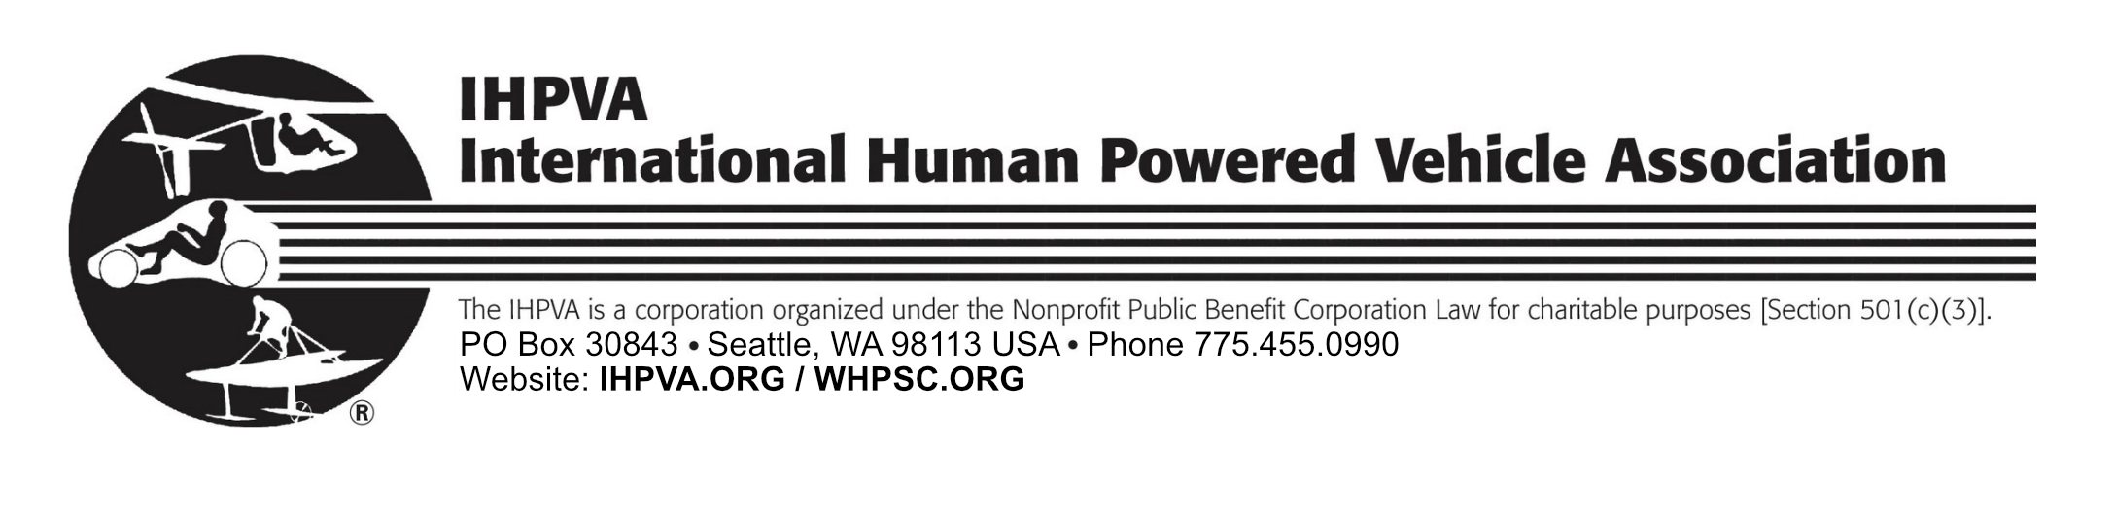

IHPVA Donation

The International Human Powered Vehicle Association is a North American-based, volunteer-run, nonprofit educational and scientific organization dedicated to improvement, innovation, and creativity in the use of human power, especially in the design and development of human powered vehicles.
Please read more about the IHPVA and their activities on the website IHPVA.ORG
Donations to the IHPVA are tax deductible in the USA under Section 501(c)(3) of the US tax code, EIN: 95-3655652.

Name __________________________________________________________
Business/School __________________________________________________
Mailing Address ___________________________________________________
City, State _______________________________________________________
Country, Zip/Postal code ____________________________________________
Email ___________________________________________________________
Phone: Work _______________________ Home/Mobile _______________________

Donation Amount :_______________ By : Check _____ or Credit Card ______

VISA/Mastercard no.:_________________________________________________
Expiration Date - Month/Year :__________ 3-digit code:______ Zip:___________
Name on Card:______________________________________________________
Signature: __________________________________________________________

Make checks payable to: IHPVA.

We are happy to accept: US Dollars, checks drawn in US dollars on a US bank account, a postal money order made out in US dollars, or a foreign draft drawn on a US bank, with identification numbers. Please do not send non-US currency or checks drawn on any other than a US bank.

Please mail this form and payment to:
IHPVA
PO Box 30843
Seattle, WA 98113 USA

Contact: ihpvatreasurer@gmail.com

