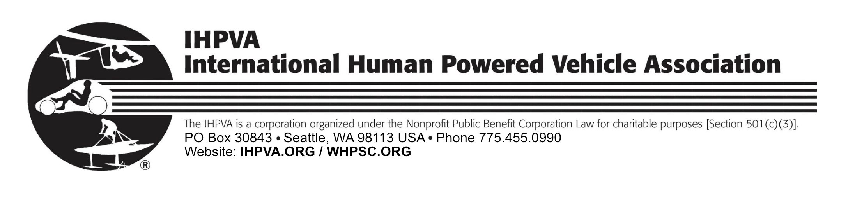

Annual Membership Form

This membership is good for one year.
Name _________________________________________________________
Business/School _________________________________________________
Mailing Address __________________________________________________
City, State ______________________________________________________
Country, Zip/Postal code ______________________________________________
Email _______________________________________________________
Phone: Work _______________________ Home/Mobile _______________________
Name & Date of Event (if applicable) _______________________________________
Date of this application _________________________
Please check if this a New Applicationr ____ or Annual renewal ____.

Membership Fee: $35.00 USD

Payment by: Check _____ Credit Card ______ Cash _____
WHPSC entrants and team members have the option of paying as part of their teams WHPSC entry fees. Check here if using this option ______.
Select WHPSC payment option: Check ___ Credit Card ___ Cash ___

Please bring a completed hardcopy form to the WHPSC event.

Fee Paid ______ USD ; Donation (optional): ________ ; Total Amount :__________
VISA/Mastercard no.:__________________________________________________
Expiration Date: Month/Year __________ 3-digit code ______ Zip ___________
Signature__________________________________________________________
Make checks payable to: IHPVA.
Please mail this form and payment to:
IHPVA
PO Box 30843
Seattle, WA 98113 USA

